Dear colleagues and members from IDEA,

With so much pain and sorrow I have to share with you that our dear friend of IDEA Ernesto Ráez Mendiola, from Perú, passed away this Thursday, March 11th. It is a big loss. I have been in mourning these days and has been difficult for me to express.

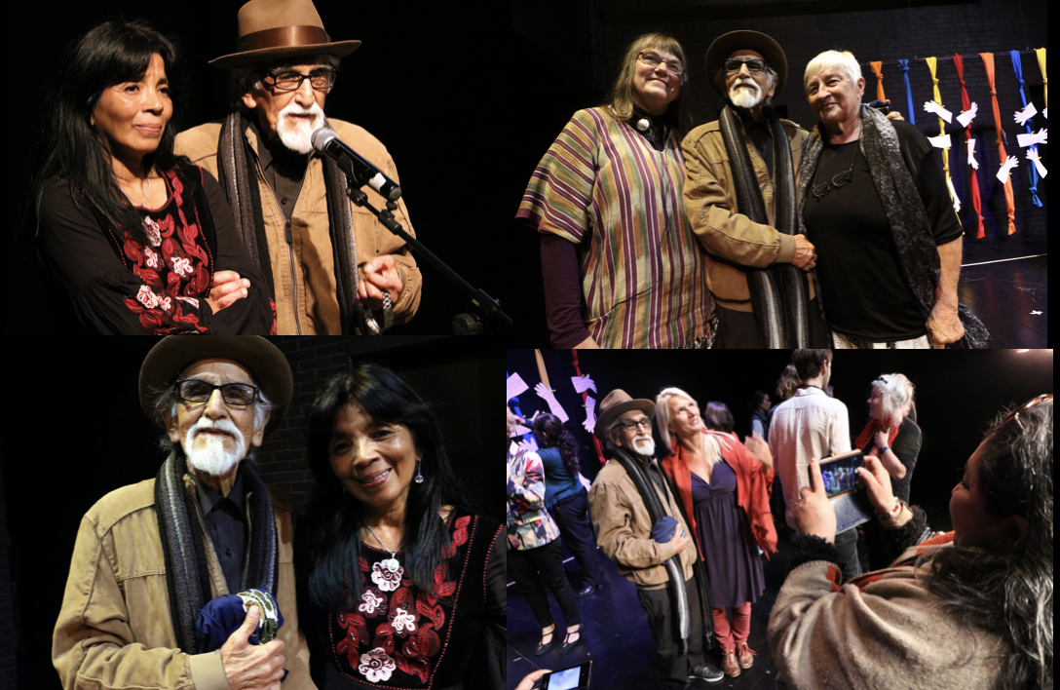
Looking back, I am so grateful to IDEA that we made for him a Tribute in 2019 during the General Council Meeting in Lima- Peru. This is why I add to this email, to those IDEA members that were present and had the opportunity to meet him on those days and other friends I know that will miss him.

Ernesto Ráez, 29 years ago, he was elected (with María Van Bakelen) to the very first board of the Executive Committee, and was elected officer from 1992-1995 and a second term to 1998. He was also part of the foundation process of IDEA since Porto in 1992, and then he invited IDEA to Lima in 1993. I get into IDEA because of him, and the Lima visit of IDEA on those days. He was our Peruvian master, theater teacher, actor, director, philosopher, our inspirational leader. He has written theater books, education art's history of Peru, blogs, unlimited conferences, workshops but overall has been a great gardener and weaver in the field of drama and theatre education.

I have written some personal words to him, that I share with you. I will make an official communication for IDEA web in addition. I attach also some photographs of the day of the tribute and his speech translated into English and Spanish version. Thanks for your words to Ernesto, dear Maria, the day of the tribute (I also attached them here). Ernesto will continue in our hearts and in the history of IDEA forever!
Thanks for your presence dear IDEA and for joining us with so great people always.sti
Lili

Dear Ernesto, dear master, I remember how you loved this phrase by Martin Buber: "I do not know where I end or where You begin because I am You and You are Me". Now more than ever, this phrase makes sense after everything you gave us and wove for the world, because now you stay in us. But it causes so much pain to recognize that there is a part of you that lives in me and another of mine, that goes away in you.
You leave us walking the talk, doing and giving to us your voice till the last moment, and we will continue listening you. How much we are going to miss every time you stood up and raised your loud voice advocating for education, for the arts, for the theater that you loved so much. Thank you for being a father of art education in Peru. Thank you for starting me in this career from Ande Peru, from the Cultural Center Nosotros, for joining and being part of the foundation of IDEA movement. Thank you for being present every time we have called you, for turning on lights at every step, for being a teacher of the twenty-second century, for always being so young, for making the stones speak, for expanding the wealth of our country in different corners, for awakening beats, for demanding us to reflect and respond to calls to action, for discovering our voices, for valuing creative feats, for creating and joining movements, for fighting for life ... just to keep on delivering. You lived in multiverses, in that Corporal self, the Social self, the Cultural and Ecological self, the Historical self and the Cosmic self, you lived in MULTIUNIVERSES in your daily life, on diverse stages, in your imagination, in that invisible world that sometimes only you could see. Thank you master, how difficult it is to say goodbye to you. I refuse to stop listening to you, that is why I will continue listening to that part of you that is in me, and I will continue reading everything you left us, enjoying your great legacy. Mission accomplished master. Peace and eternity.

