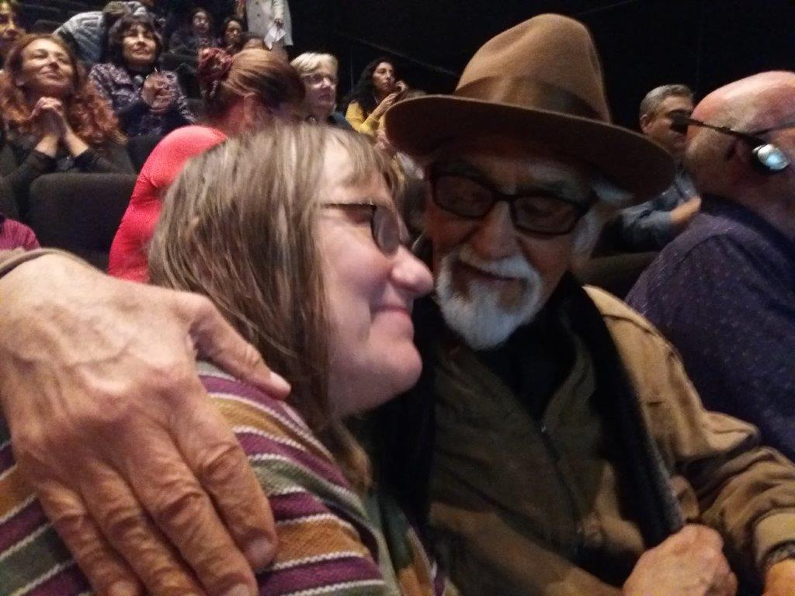
Dear Lili, all Peruvian friends and you other IDEA people,

What a big, big loss this sad news gave us! Thank you for sharing the memory photos and texts.

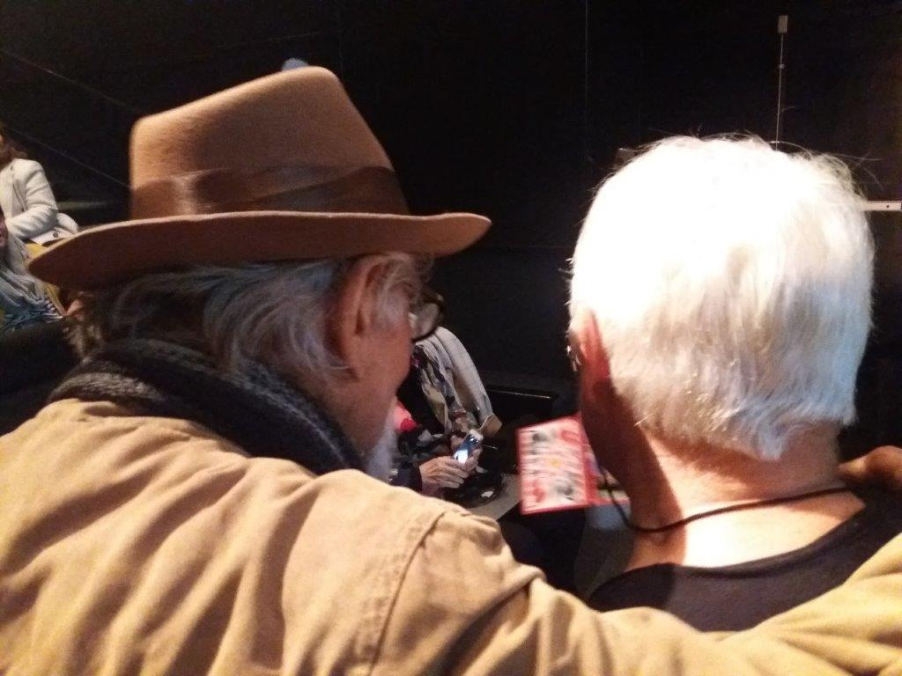
I attach here some photos of this forever in our memories living Ernesto, with whom I had the pleasure and privilege to be in EC from 1995-1998. I am so grateful for that and also for the delighting and warm re - meeting after years in Lima 2019! He will stay in my (and all our) heart forever.
The first photo (152214) is known among all FIDEA members, because it was published with my article about PERU GCM in FIDEA journal 2/2019.

with sad but comforting hugs, Tintti Karppinen

