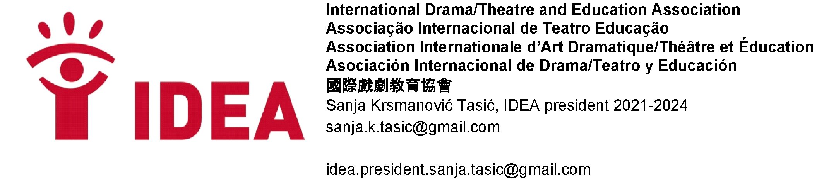
IDEA DAY MESSAGE 2025
This year it will be the 18th time we are celebrating IDEA Day ever since Tintti Karppinen proposed it should be celebrated. Themes for the IDEA Day celebration have changed over the years. This year, the year when we find ourselves in confusion about the darkness and destruction that seems to prevail in the world, we have decided to have the theme of “Drama/Theatre for Hope” as the main focus of 2025 IDEA Day.
I would like to give a subtitle of my IDEA DAY message as “Hope in Action”.
Just being and hoping in these radical times is not enough. We are not in the position to sit and wait for better times to come, for things to resolve by themselves.
Rebecca Sonlit writes that hope is “an embrace of the unknown and the unknowable” and also “an axe you break down doors with in an emergency”. We are in the times of “radical hope” as explained by Jonathan Lear.
“Radical hope means grounding ourselves in the possibilities and making proactive efforts to transform them into promise. It is believing that there are ways to move forward, to survive, resist, and prevail, without knowing exactly where we will be when we arrive.”

The work we do, in our field of drama/theatre and education implies actually that, reimagining the future, recreating the world and ourselves in every drama class, through every process.
Through our work we present ourselves and our essence in the world. We have the possibility to transform in this process, and by transforming ourselves we transform the world. I can witness this impact on drama/theatre pedagogues, teachers, students, theatre professionals, as I travel around the world attending events organized by our members, conferences, congresses festivals where I have the honor to deliver keynote speeches, speak on panels or conduct workshops.

Just recently at the Congress organized by the Contemporary Drama Association from Türkiye in Ankara, during the process of describing their life journey and mapping all the most important life changing events in my devising workshop, almost all the participants marked the year in their life when they encountered drama/theatre and how it changed their life. Some described it like flowers starting to bloom in their hearts, some described it as at last finding peace and creativity for themselves. Some as at last expressing, resisting, creating for a better future.
In the Conference in Bucharest, organized by UNATC, a young mother said that when she watched her children perform and present in a drama/theatre class, it is as if she saw them for the first time for who they truly are. Drama/theatre helps us get to know and understand ourselves and understand the world we live in. But it also has a pro-active role of changing the reality at least in this time while the workshop, class, drama process, theatre activity is happening. And the only way to change the present is first of all to start imagining what it could actually look like.

I believe that we are capable of making this effort, of opening this possibility of casting the light on us, making us visible, the goodness and hope we bring with what we do, also bringing the light with us, the light of hope and change. We must change the paradigm of being in the margin to being in the center of education, life and humanity. What we bring are essential skills needed for us as humans to be able to sustain, survive and develop. We have the power of confronting all the dark issues of AI and digitalization, on the other hand embracing the good points it brings, by fighting for our work that demands physical presence and embodied practices.

We must convince the world that by marginalizing us, it is marginalizing the possibility of wellbeing and inner growth, and diminishing the possibility of working on the “ecology of the soul”. We do need to work on it as diligently as we work on ecology in the world around us. Our inner worlds are as fragile, and sometimes polluted, darkened by so many factors.

This resilience, strength, this way of continuing, must be expressed firmly and patiently for all to see. For this year’s UNESCO International Week of Arts Education we decided to use strong words, just as we made the decision in our declarations not to ask any more, but to demand. And words have energy in themselves.
So we will not bow down, but continue to create hope in action, in every class, every workshop, every time we do our work in drama/theatre and education.

We will not bow down, but create hope in action.

Sanja Krsmanović Tasić
IDEA President (2020-2027)

We arts educators, from all areas of arts, will not bow down!
Through arts in education we address social justice and climate justice issues, we foster empathy and understanding.
Facing the current state of global violence, we will not bow down!
We pledge for artistic expression as a tool for dialogue, reconciliation, and inclusivity.
Facing the current state of bipolarization, racism and xenophobia, we will stand up strongly against them! We pledge for democratic citizenship and peacebuilding.
WAAE statement for the 2025 UNESCO Arts Education Week

